**SMART VENDING MACHINE using DRS AWS**

Name of the candidates: Hariharan NKS, Abishak S

Department of Electronics and Communication Engineering,

Chennai Institute of Technology, Chennai, India

# **ABSTRACT:**

The presently existing replenishment device may be handiest systematically reviewing the inventories. Whereas, there are ongoing vending machines that mayn’t be able to provide or discover whether the substances are doing nicely to be replenished or no longer. This effects in an inefficient replenishment policy and there will regularly be inventory-out among the products. This undertaking intends to provide the automatics replenishment of smart merchandising gadget with the intention to provide and support inventories to the administrator. Amazon sprint replenishment service (amazon DRS) permits while the vending device is about to run out of the stock stock/product, it mechanically locations orders on amazon, administering which of the supplies may be wished for replenishment. By executing this venture, inventory out of the vending machines may be prevented and a green manner of the replenishment system can be carried out.

**INTRODUCTION:**

**OVERVIEW OF THE SYSTEM:**

Vending machines gave consumers convenience, and they have since become an integral part of the consumer lifestyle. Service functions, on the other hand, continue to exist as a method aimed towards society and the general public, and research is being performed to improve their operation and performance.

In the vending machine market, more innovation has been given to the collaboration with the supply chain, specialising in the development of replenishment strategy, due to an increase in the competitive market and short product life cycle.

To suit in with frequency, internal control, and satisfactory manage, extra replenishment functions are critical. The traditional replenishment focuses on solving estimations primarily based on historical stock records. When using a ancient evaluation technique or system to top off the gadgets of vending machines, a trouble develops, and it's far only appropriate when demand is extremely stable and as a result the replenishment price is excessive; the call for merchandise fluctuates in an excessively vending system. The task's use of amazon DRS provides value by allowing vending machines to mechanically replenish inventory through placing orders on amazon thru the DRS provider.

**OBJECTIVES OF THE PROJECT:**

Smart Vending Machine using Amazon DRS can be used in many ways as follows:

* + - Main Objective of the project, is to design low-cost Smart Vending machine by utilizing ESP32 and
    - demonstrate end to end use cases of Amazon DRS Service with easy and interactive end user interaction.
    - It will automatically replenish the product of vending machines easily form Amazon.com through Amazon DRS service.
    - It will be best suited for the small-scale Vending machines such as Snacks Vending machine, Beverage Vending machine, Sanitary needs Vending machine.
    - Reduces the relationship between the admin/owner of the Vending machine and supplier to the minimal level.

**PROBLEM STATEMENT/DEFINITIONS:**

Nowadays Vending Machines use has increased drastically which is making it easy for consumers and providers. Existing replenishment services of vending machines are high cost, not easy to implement and use by laymen. Having better replenishment functions is a key to fit in with frequency, internal control and quality control.

A vending machine generates an average of Rs.6000 in revenue every week for the person who owns and operates it. This equates to more than Rs.25000 each month. As a result, you can see how a few machines producing an average might start bringing in good earnings and in desirable places. In India, the cost of setting up an entry-level vending machine can range from Rs.2L to Rs.3L. However, we cannot imagine automatic replenishment service for this price in this form of vending.

To suit in with frequency, internal control, and satisfactory manage, extra replenishment functions are critical. The traditional replenishment focuses on solving estimations primarily based on historical stock records. When using a ancient evaluation technique or system to top off the gadgets of vending machines, a trouble develops, and it's far only appropriate when demand is extremely stable and as a result the replenishment price is excessive; the call for merchandise fluctuates in an excessively vending system. The task's use of amazon DRS provides value by allowing vending machines to mechanically replenish inventory through placing orders on amazon thru the DRS provider.

**BENEFITS OF THE PROJECT:**

* + - It is cost effective
    - Easy to Implement in existing Vending Machine
    - Reduction of admin/owner and provider gap relation
* Useful for existing low-cost entry-level Vending Machine

**PROJECT SCOPES / CONSTRAINTS:**

When the vending machine's stock inventory/product is ready to run out, **Amazon Dash Replenishment Service (Amazon DRS)** automatically puts orders on Amazon, alerting the administrator to which supplies need to be replenished. Stock-outs among vending machines will be avoided as a result of the implementation of this project, and an effective replenishment mechanism will be created. We're going to make a vending machine with three slots for inventory each. Simple Notification Service (SNS) Topics are used by the Dash Replenishment Service (DRS) to alert you (the device maker) of changes to device status, order status, subscription status, and more. And Login with Amazon (LWA) allows you to safeguard your customers' information by utilizing Amazon. com's user authentication mechanism. Amazon's login is based on OAuth 2.0, which is widely used for user-authorized exchange sites. Inventory listings with unique ASINs (Amazon Standard Identification Numbers) will be linked to each slot in the DRS API.

**LITERATURE REVIEW**

**EXISTING METHODOLOGY:**

**Fuzzy Logic Based Replenishment System for Smart Paper Dispensing Machine**

The clever system is managed with the aid of a fuzzy machine that outputs crisp values which are represented by way of the resupply alert index (rai), a decimal wide variety representation that stages from zero to 3, with zero representing "pressing" popularity and 3 representing "good enough" repute; this tells the operator which substances want to be replenished. By implementing this check, stock-outs of vending machines may be avoided, and a green replenishment system might be implemented. The software used to construct this device is a paper allocating device that covers the call for at the university of Santo Tomas' School of Engineering and compares it to other digital simulations. The RAI was able to demonstrate to the supplier that it can provide statistics on which merchandising machine and which of its goods has the highest replenishment urgency through simulations.

**Smart Vending Machine Based on SMS Gateway for General Transaction:**

The layout and experimental investigations of merchandising machines for workplace stationery transactions are offered in this observe. The proposed vending machine has the following advantages: transactions may be done using short message system (SMS), all transactions can be monitored on line through the proprietor the use of android, the vending device has an early caution gadget (EWS) while the machine is in problem, and it additionally has a battery backup whilst the power goes out, and there's no want to make special agreements with banks or telecommunication providers.

**HARDWARE AND SOFTWARE DESCRIPTION:**

**INTERFACING I2C LCD WITH ESP32**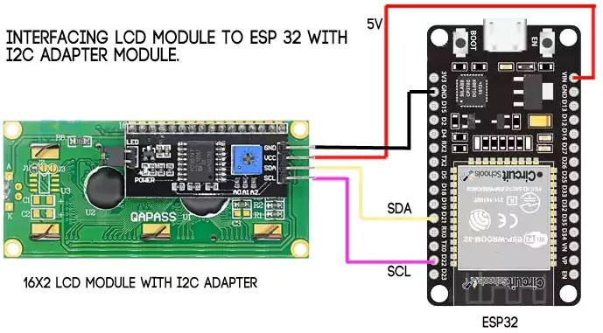

**ESP32**:

Esp32 is a series of low-value, low-strength microcontrollers with built-in wi-fi and twin-mode Bluetooth. The esp32 own family consists of integrated antenna switches, rf baluns, energy amplifiers, low-noise acquire amplifiers, filters, and electricity manage modules, in addition to a ten silica Tensas lx6 microprocessor in both dual-core and single-center versions. Expressive structures, a shanghai-based totally Chinese startup, designed and evolved the esp32, that's produced through TSMC the usage of their 40 nm era. 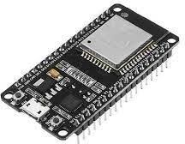

**ESP 32**

**REED SWITCH and NEODYMIUM MAGNET:**

It consists of a hermetically sealed glass envelope with a pair of contacts on ferrous metal reeds. The contacts might be typically open and close when a magnetic field is applied, or normally closed and open when one is applied. A coil may be used to activate the switch, or a Neodymium magnet may be brought close to the switch to create a reed relay. The reed switch will return to its original position after the magnet is removed from the switch.

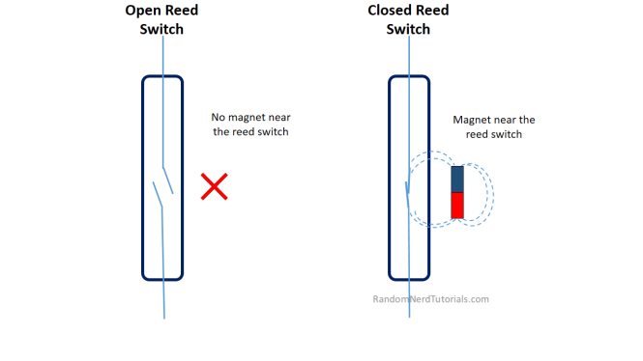

**Software description:**

***ARDUINO IDE:***

A multiplatform (Windows, macOS, Linux) application is created in a C programming functionality in the Arduino Integrated Design Environment (ADE). For programmer coding, we utilize Arduino software. This is a useful tool in the software industry.

***AMAZON SNS SERVICE:***

Amazon Simple Notification Service (Amazon SNS) is a fully managed messaging service, which may be used to communicate applications to applications (A2A) or applications to people (A2P).

SNS Topics are used by the Dash Replenishment Service (DRS) to alert you (the device creator) of changes to device status, order state, subscription status, and more.

***AMAZON DASH REPLENISHMENT SERVICE (DRS):***

The Amazon dash refill (DRS) service allows linked products, like a printer that requests higher inks, to reserve actual things from the Amazon while compounds run low. You may utilize Amazon dash filling systems, customer service and the completion community by using the amazon authentication and payment systems, providing your clients affordable costs, excellent options, and dependable conveyance.

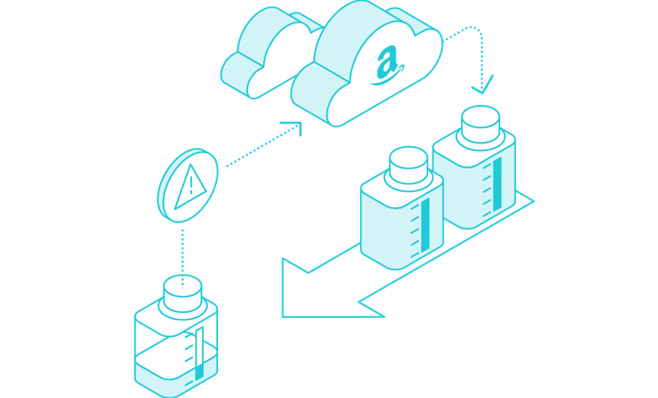

**LOGIN WITH AMAZON (LWA):**

Login with amazon lets you shield your customer data by way of leveraging the consumer authentication device utilized by amazon.Com. Login with amazon is based on oaths 2. Zero, which has been widely adopted for consumer authorized exchanges across websites.

**BLOCK DIAGRAM:**

The block diagram of Smart Vending Machine using Amazon DRS is shown in Figure below, which depicts the overall functioning of the module and proposed system that incorporates IOT based automated system.

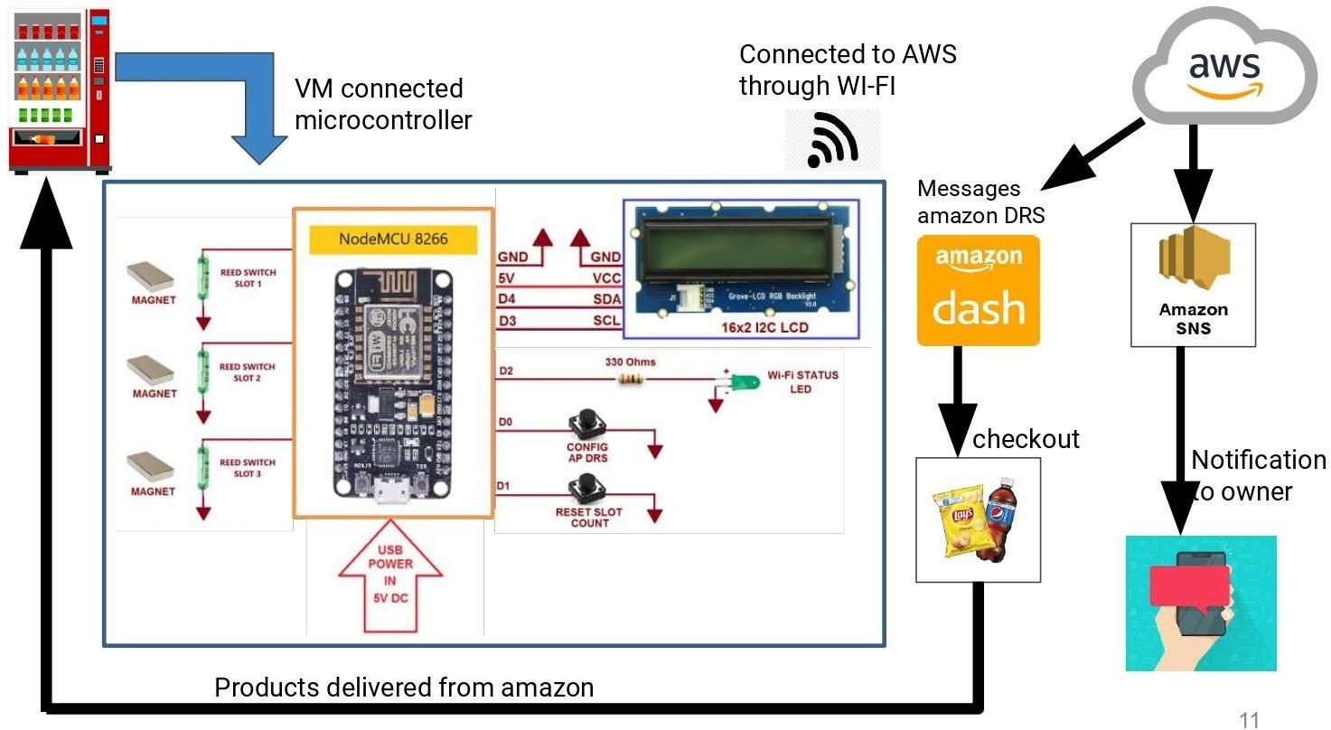

**BLOCK DIAGRAM OF THE PROPOSED SYSTEM**

**WORKING OF THE SYSTEM:**

The assignment is illustrated in a block diagram in the discern 5.1. It breaks down the system into different chunks to make it easier to visualise and interpret. It outlines the system's various blocks and illustrates which components receive output from the esp32 and which provide input to the esp32. In our task esp32 acts as a microcontroller. The vending machine will have three slots each for slot1, slot2 and slot3. Listed with ASINs **(Amazon Standard Identification Number)** of slot1 product will be mapped with slot1, list with ASINs of slot2 will be mapped with slot2 and list with ASINs of slot3 product will be mapped with slot3. Webpage that is linked with Amazon DRS service, so users of the vending box can register and select products for each slot based on their preference using Product ID and serial number of vending machines. The Reed switch is connected to each of the slots with Neodymium Magnet, which is used as a slot counting indicator. When the slot reaches the minimum threshold value (for example 5 count in slot), then it will send a message/token to Amazon DRS for product replenishment in slots. Dash Replenishment Service (DRS) uses SNS Topics to notify you (the device owner) of changes to device status, order state, subscription status, and more. End admin/owner facing web page for Product registration is done separately for the authorization code. All current information (i.e., Tokens, AP Credential, Slot Status) stored in eeprom of ESP32 every time it changes. So, on every power cycle, the Vending Machine retains the latest information.

Then a successful trigger of the Amazon DRS powered Vending machine enables the admin/owner to check out the product and acknowledgement of the product through the registered mail-id. Then products from Vending machines will be delivered by Amazon.

**RESULT AND DISCUSSION:**

Because the end customer must register the product with Amazon DRS and generate a 20-character Authorization code, I've built a Web page for registering the product with Amazon DRS from the customer's end. Once a 20-character authorization number has been created during the registration procedure, it will be utilised to set up the vending machine to allow for automatic product reordering without the need for human interference.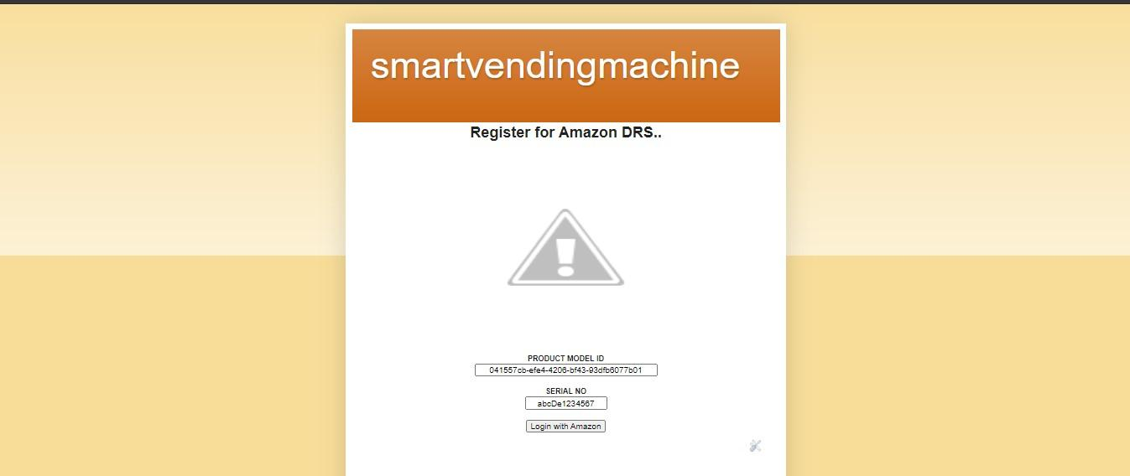

# 

# **Product Registration Web Page**

When the ESP32's config button is pushed, it becomes an access point (AP) that broadcasts its SSID (SVM). End users can connect to this AP via their mobile phone or computer, and the information is sent to the browser.

Chosen network SSID, Password, and Authorization code are established using the save option in the browser, and the ESP32 connects to the preferred network automatically.

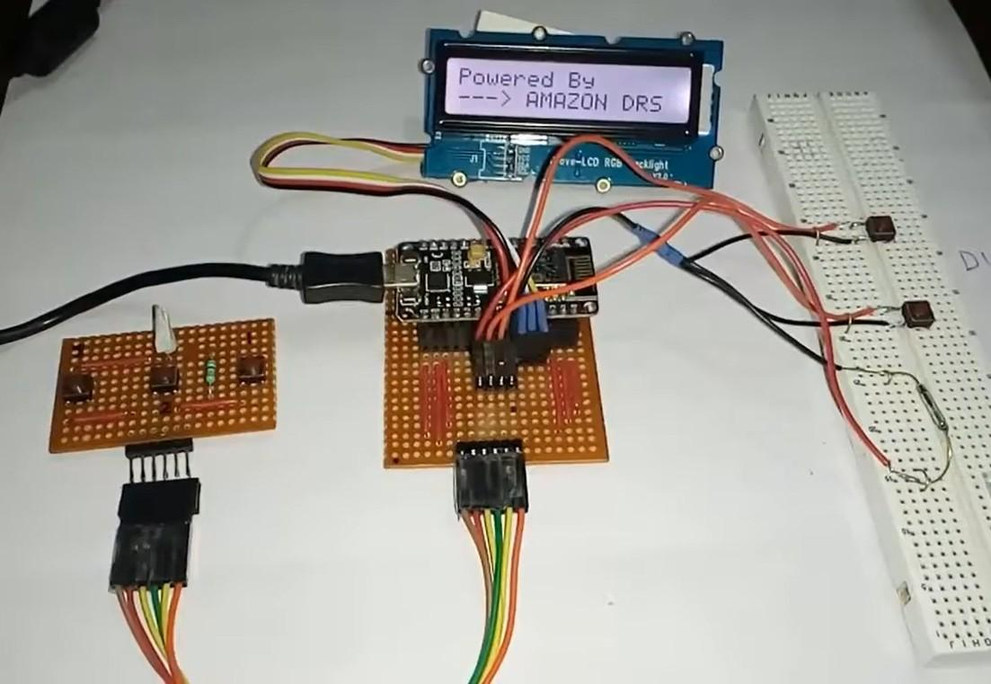

# **demo photo of project**

The authorization code can only be used once. And it's good for around 15 minutes. This duration isn't specified in the Amazon DRS documentation, but it's not more than 15 minutes in my experience.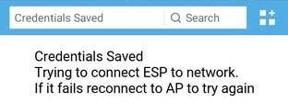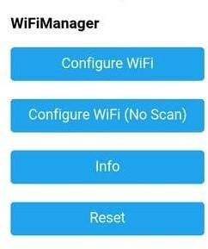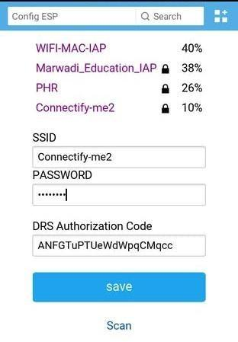

# **Config hosted by ESP3**



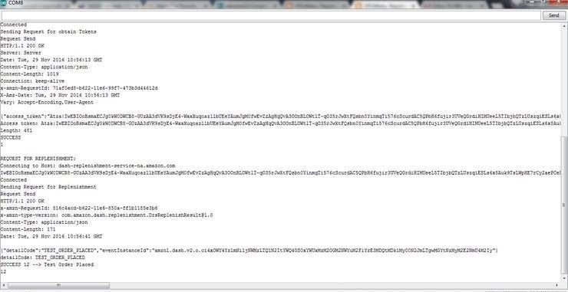

# **esp32 terminal showing successful replenishment process on trigger of reed switch**

**CONCLUSION:**

The project SMART VENDING MACHINE USING AMAZON DRS using IoT

has been implemented successfully and has applications in many ways especially in Vending machines. This is a very advantageous technique which is useful in many ways. **Amazon Dash Replenishment Service (Amazon DRS)** enables when the vending machine is about to run out of the stock inventory/product, it automatically places orders on Amazon, this gives the administrator which of the supplies needed replenishment. Easy to Implement in existing Vending Machines. Reduction of admin/owner and provider gap relation and it is Useful for existing low-cost entry-level Vending Machine. The design of this project enables the existing vending machine into an automatic smart replenishment vending machine with the cost effective.

**REFERENCES**

**PAPERS:**

The following are the reference papers which we used for our project

1. Anupama Kaushik **“IOT-An Overview**”, International Journal of Advanced Research in Computer and Communication Engineering, Vol. 5, Issue 3, March 2016.

[2] A. H. V. Dela et al., "**Fuzzy logic-based replenishment system for smart paper dispensing machine**," 2015 International Conference on Humanoid, Nanotechnology, Information Technology, Communication and Control, Environment and Management (HNICEM), Cebu, Philippines, 2015, pp. 1-7.

[3] S. HUMCO, P. Sukarno and R. Yasi Randi, "**How Can Fingerprint Improves The Payment Experience of a Drink Vending Machine?"** 2020 8th International Conference on Information and Communication Technology

(ICOICT), Yogyakarta, Indonesia, 2020, pp. 1-6.

[4] S. M. S. Arifin et al., **"Smart vending machine based on SMS gateway for general transactions,**" 2017 15th International Conference on Quality in Research (QIR) : International Symposium on Electrical and Computer Engineering, Nusa Dua, Bali, Indonesia, 2017, pp. 34-39.

[5] L. Liu, J. Cui, Y. Huan, Z. Zou, X. Hu and L. Zheng, "**A Design of Smart Unmanned Vending Machine for New Retail Based on Binocular Camera and Machine Vision,"** in IEEE Consumer Electronics Magazine.

[6] Sooraj P1, Bony Mons2, Dr Jinshan Kuruvilla3 **“IoT Based Vending Machine with Cashless Payment”** International Research Journal of Engineering and Technology (IRJET) Volume: 06 Issue: 06 | June 2019.